[Scope Of The Project And Scheduling](https://smartinternz.com/Student/challenge_workspace/2174" \l "collapse1)  :

* The project is realised and divided among the team memebers for successful execution

The divided parts of the project is:

**Authentication with twitter API**

**Fetching Tweets For Corona Virus**

output:

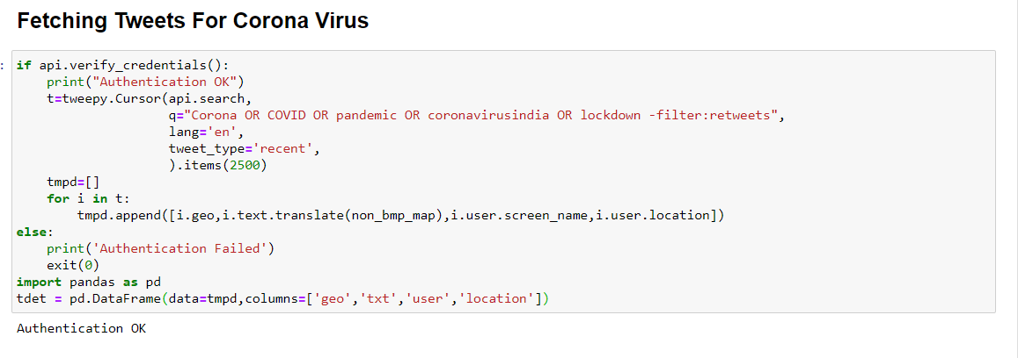

**Cleaning our tweets**

here we are cleaning the tweets as per our needs.

**Calculating Sentiment**

we are calculating the polarity of the  sentiments from the tweets.

**Classifying the sentiments**

now we  are classifying the sentiments based on polarity as positve ,negative,neutral.

**Preparing data for Scatter Plot**

**output:**

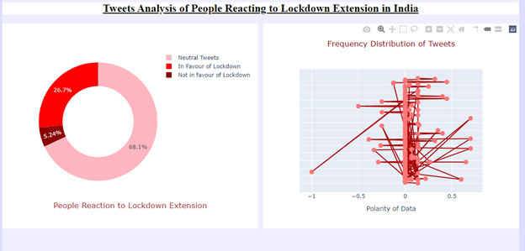

**Plotting the pie chart**

**output:**

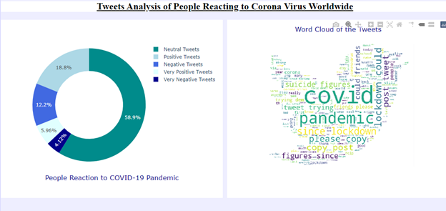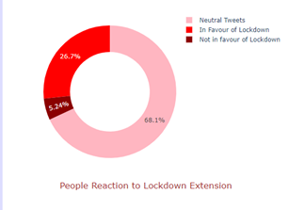

**Wordcloud:**

**output:**

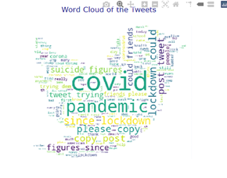

**Final Layout:**

**output:**





Thank you ,this project is being prepare By :Soumo Roy,Sausamya Mitra,Sayak,Sanjukta Ganguly.